Minutes of the Whitehorse Canoe Club Committee Meeting

May 2025

Details: 13th May 2025
Present: David G, David O, Alison, Linton, Des
Apologies: Sean, Geoff, Jimmy

Meeting Opened: 8:21pm

Topic | Content | Individuals Assigned
Acknowledgement to Country | Club president Dave Green read the Acknowledgement to Country statement to open the meeting. | David G
Previous minutes | Committee Meeting Minutes 04/03/25 – Approved | David G
Treasurers Report | Current Balance: $10,793.05 as of 12th May 2025 | David O
 | 8,042.35 in the Sandhurst Account and $2,750.70 in the Trading Account.  (Full report attached) | David O
Trips since last meeting | - Easter Thomson River Friday Trip Walhalla Bridge to Bruntons Bridge.  - Easter Thomson River Saturday Bruntons to Cowwarr.  - Homestead to Wittons Sunday 4th April.
Future Trips | - Kings Birthday Weekend – Mitchel River 7th – 9th June.  - Callendar Events
New members | Membership update since last meeting (4th March 2025):  Current membership is 89 members an increase of 7 members since last meeting.
  Martin Evans
  Laura Evans
  Dan de Chalain
  Amelie Evans
  Isla Evans
  Christopher Lansell
Correspondence | - Automatic Renewal option available from Paddle Vic.  - Discussed and decided to not activate either as mandatory or optional.  - Paddle Australia equipment Insurance.  - Des to forward to club members).  - Strategic Plan from Paddle Vic.  - PV run webinar highlighting the strategic plan. | Des
Old Business / Outstanding tasks / Ongoing | Child safe clubs / national integrity. By exception. We agree to commit to the child safe national integrity framework.  No reportable incidence. | David G  Alison
 | Grants for skills development. By exception. None that apply to us. | Alison
 | Merchandising – Red bubble – In Beta testing | Linton
 | Asset Tracking sheet in progress.  - Continue to update as required – Up to date.  - Note: Frame not with raft. | Linton
 | Discussed promoting club and white-water kayaking.  - Alison is drafting a survey to understand members’ desires and interests for the club. | Alison
 | Subsidise skills improvement courses.  - Enquire with Mick Ramsay (Grade 2 Guide Training) and Sean Smith, re possible course  - Enquire re Tasmania course | David G Alison
 | Locate Old WHCC Newsletters  - Everything Linton has electronically is on the Google drive.  - Linton checked whether old physical newsletters are in the electronic format. They are not. Alison to check other records in attempt to locate. | Alison  Linton
 | David Osborn has a Zoom account for remote attendance of meetings.  - Bring up at AGM to allow remote members to hold office positions | David G
 | New improved maps on Avenza and club website.  - Email sent to members.  - David G to draft message, highlighting availability of new maps to broader paddling community (e.g. Facebook – Friends of page and who wants to go paddling etc.). | David G.
 | Remove Lawrence as a signatory from Bendigo Statement account. | David O
New Business | No new business recorded

Note: All items from previous meeting minutes which are not listed in the above minutes are deemed to be resolved and therefore closed and not included in the above minutes.

Meeting Closed: 9:17pm
Next Meeting: 24th June 2025
7pm for meal and 8pm for meeting at Mitcham Hotel

WHITEHORSE CANOE CLUB
To: | Committee
Date: | 12 May 2025
Subject: | Treasurer Report
From: | David Osborn

Finances
Please find below a Profit & Loss for the period 1 July 2024 to 12 May 2025.
My comments are:
- Whitehorse is in a strong position with $8,042.35 in the Sandhurst Account and $2,750.70 in the Trading Account. That is 4+ years of expenses in the bank if it anticipates a similar level of activity to last year.
- Membership numbers are now similar to same time last year and income from fees is expected to be similar to last year. The new memberships are consistent with the timing estimate that was discussed last meeting.
- The Profit & Loss account has been compared to a budget and forecast updated as at 12 May 2025. The updates reflect the actual cost YTD on various items and importantly no planned capital purchases. I am still forecasting $500 for river maps but at this stage that also looks like nil cost.
- The current forecast surplus for the year is $1,326 agains a budget of $695
- The main expenditure since the last meeting was web hosting costs of $253.
- Since this report I have transferred another $2,000 to the interest bearing account at Sandhurst Trustees. There is over $8,000 at call in Sandhurst if the club wishes to do anything. There is $750 in the Bendigo Trading account.
- The rules of the Sandhurst Account are that funds must be initially lodged for 90 days and thereafter they are at call. The $2,000 will be at call in 90 days.

Membership
1. Geoff Burkitt has separately reported that current membership is 89 members an increase of 7 members since last meeting.

Profit & Loss Account

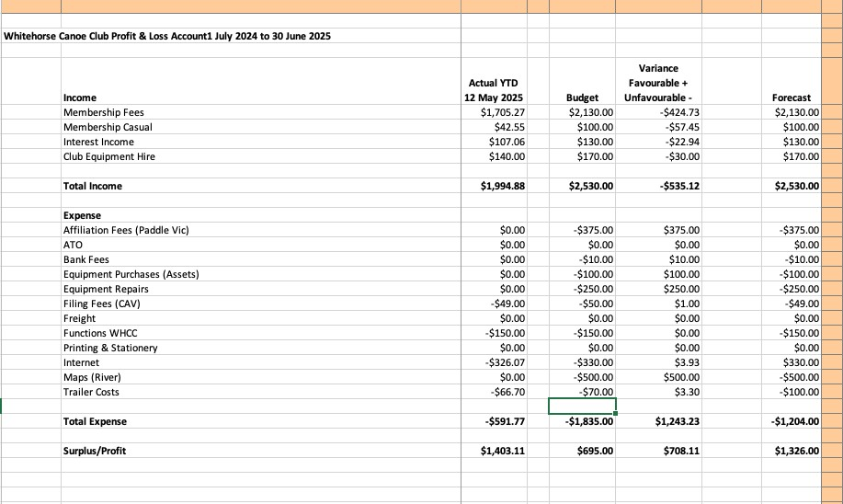

Other Matters:

- Circulating emails confirmed that we do not wish to vary the standard Paddle Australia membership email text.
- Paddle Australia can also rollover a membership and charge a members credit card. This needs to be discussed by Committee. I would not support automatic member renewals for reasons I will outline at the meeting.
- Circulating emails also confirmed that the Committee does not intend to promote the Paddle Australia insurance policy for gear to Whitehorse members.

